Packet Tracer – Skills Integration Challenge

1. Topology

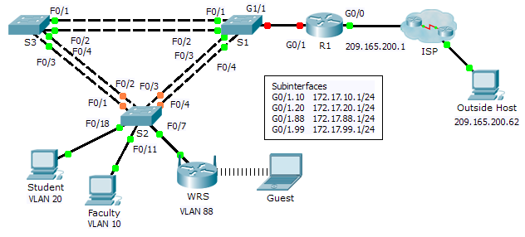

1. Addressing Table

|  |  |  |  |  |
| --- | --- | --- | --- | --- |
| Device | Interface | IP Address | Subnet Mask | Default Gateway |
| R1 | G0/0 | 209.165.200.1 | 255.255.255.224 | N/A |
| G0/1.10 | 172.17.10.1 | 255.255.255.0 | N/A |
| G0/1.20 | 172.17.20.1 | 255.255.255.0 | N/A |
| G0/1.88 | 172.17.88.1 | 255.255.255.0 | N/A |
| G0/1.99 | 172.17.99.1 | 255.255.255.0 | N/A |
| S2 | VLAN 99 | 172.17.99.32 | 255.255.255.0 | 172.17.99.1 |
| WRS | Internet | DHCP Assigned | DHCP Assigned | DHCP Assigned |
| LAN | 172.17.40.1 | 255.255.255.0 | N/A |

1. Scenario

In this challenge activity, you will configure VLANs and inter-VLAN routing, DHCP, and Rapid PVST+. You will also be required to configure a Linksys router for wireless connectivity with wireless security. At the end of the activity, the PCs will not be able to ping each other but should be able to ping the outside host.

1. Requirements

R1 Configurations

* Enable and configure the subinterfaces with the following requirements:
  1. Configure IP addressing for the subinterfaces according to the Addressing Table.
  2. Configure the appropriate dot1Q encapsulation.
  3. Configure VLAN 99 as the native VLAN.
* Configure DHCP pools for VLAN 10, 20 and 88 with the following requirements:
  1. Name the DHCP pools **VLAN10**, **VLAN20**, and **VLAN88**.
  2. Set the default-router within each pool as the subinterface address.
  3. Exclude the first 20 addresses for VLAN 10.
  4. Exclude the first 20 addresses for VLAN 20.
  5. Exclude the first 10 addresses for VLAN 88.

Switch Configurations

* Configure Rapid PVST+ on all switches.
* Configure the IP addressing according to the Addressing Table on **S2**.
* Configure the default gateway on **S2**.
* Most of the VLANs are already configured. Create a new VLAN 999 on **S2** and name it **Blackhole**.
* Configure the following static ports for **S2**:
  1. F0/1 – 4 as trunk ports as the native trunk for VLAN 99.
  2. F0/7 as access ports in VLAN 88.
  3. F0/18 as access port in VLAN 20.
  4. F0/11 as access port in VLAN 10.
  5. Shut down all unused ports and assign them as access ports in VLAN 999.

WRS Configurations

* Set **Internet Setup** to receive IP addressing from R1. You may need to go to the **Status** tab to release and renew the IP addressing. Ensure that **WRS** receives full IP addressing.
* Configure **Network Setup** according to the Addressing Tableso that the guest devices receive IP addressing.
* Configure wireless settings.
  1. Set the network mode to **Wireless N-only**.
  2. Rename the SSID **WRS_Guest** and disable SSID broadcast.
* Configure wireless security. Set the authentication type to **WPA2 Personal** and configure **guestuser** as the passphrase.

PC Configurations

* Verify that **Student** and **Faculty** PCs received full addressing from **R1**.
* Configure **Guest** to access the wireless LAN.
* Verify **Guest** received full addressing.
* Verify connectivity.